Currently on our project we are not able to open the manage dropdown ,they don’t work because we dint import bootstrap javascript code and supporting js we will not import them because we want only angular to do it

so we will make our own directive to do it

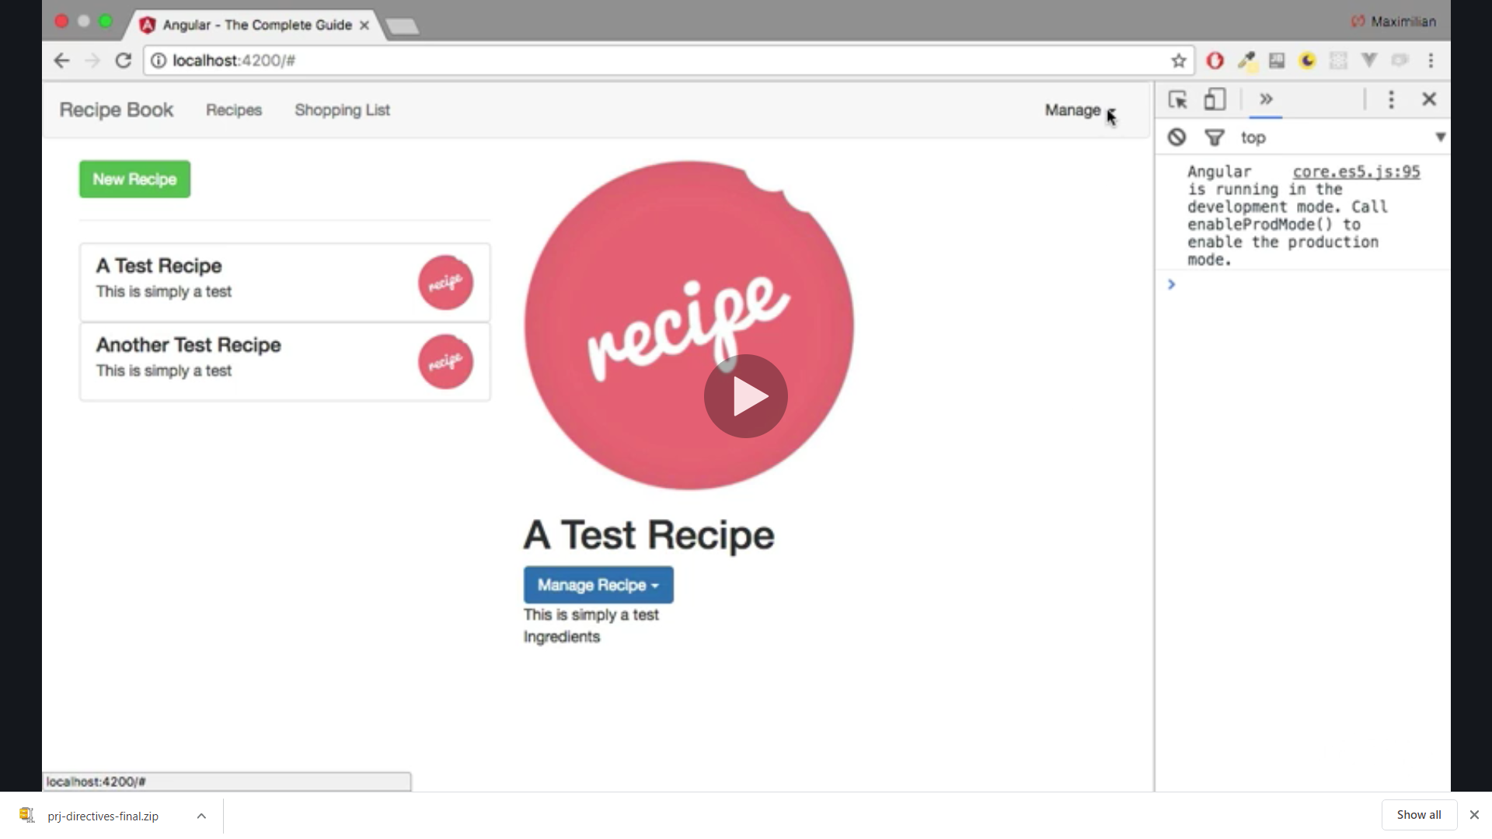

We create a new file in the shared folder , we can also use cli to generate directive but we did here by creating ourself

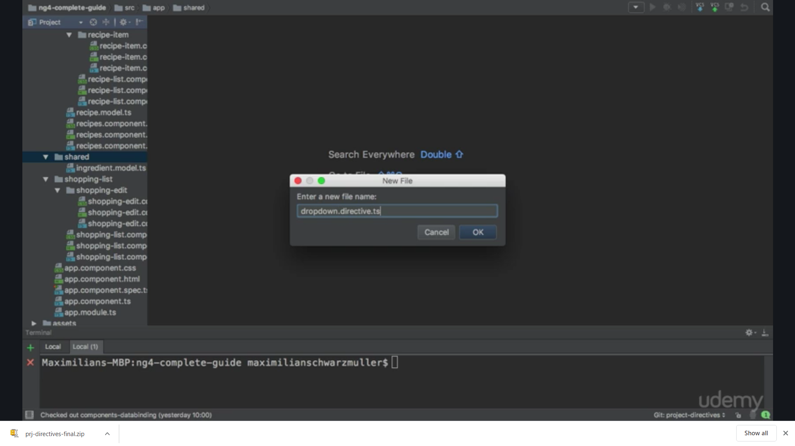

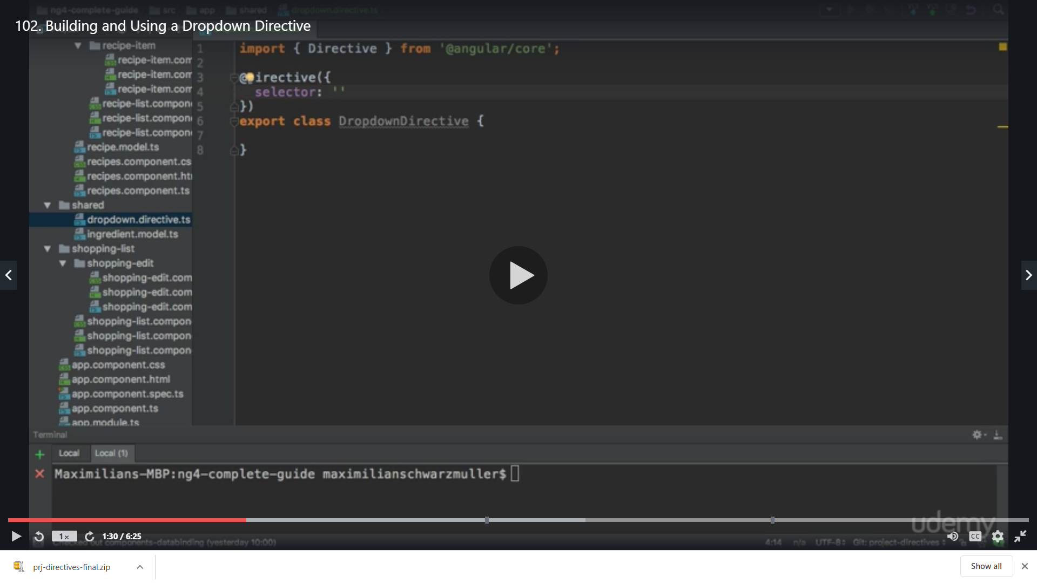

We will use attribute selector so we will enclose the name in [] ie [appDropdown]

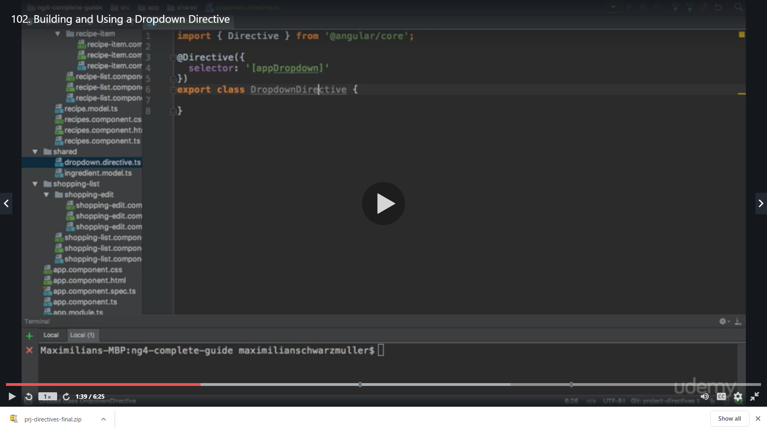

Now we want to add a functionality which allows us to add a certain css to the element this directive sites on is clicked and remove the class on when we click again ie: we want to create a method which listens to the clicks and toggles to whether some calss is attached to it or not

So we will see which class we need to attach

We have our recipe-details.component.html we add open here

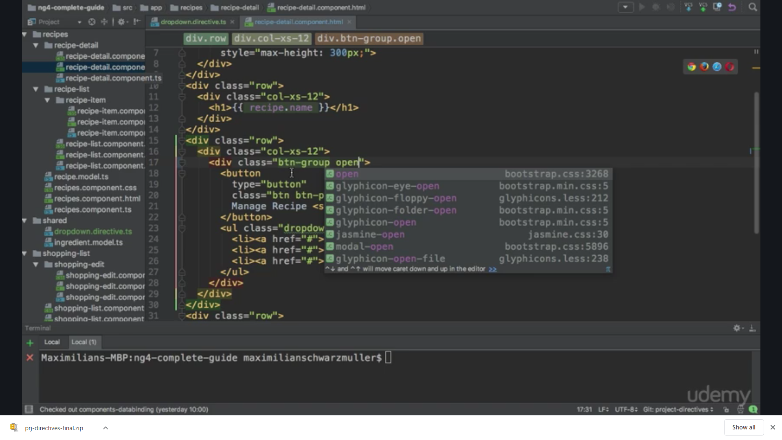

We see that when we click on recipe it gives already open dropdown

(Facing issue in my system due to bootstrap version so the open class in not working)

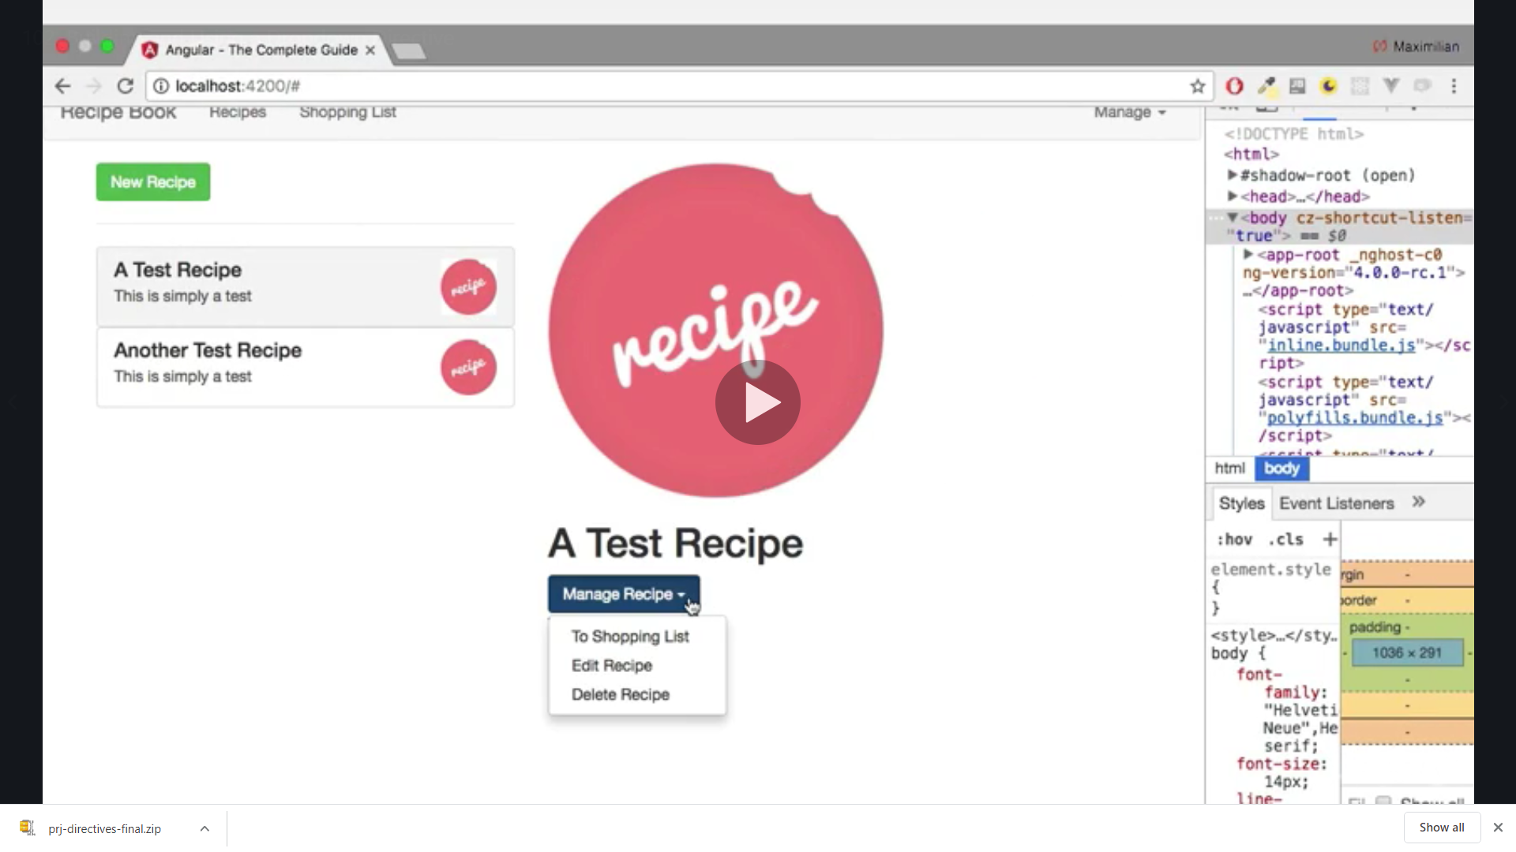

First we listen to the click event

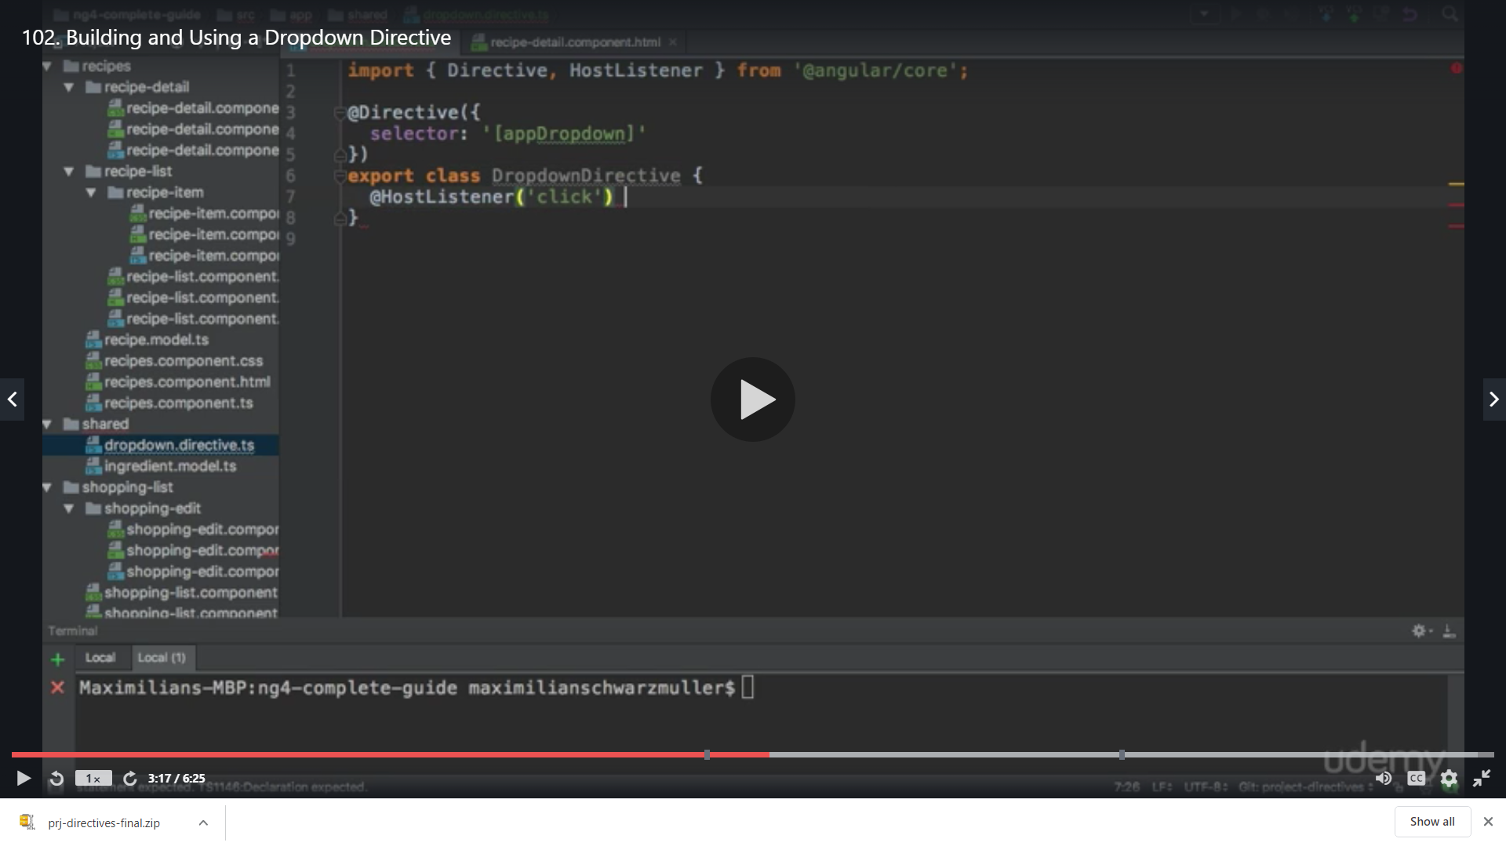

Then we want to execute toogle open or closed

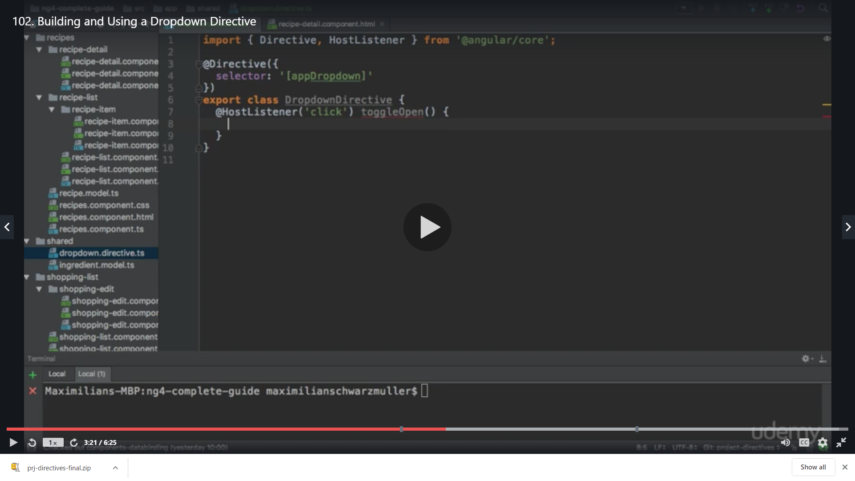

We add a property as false

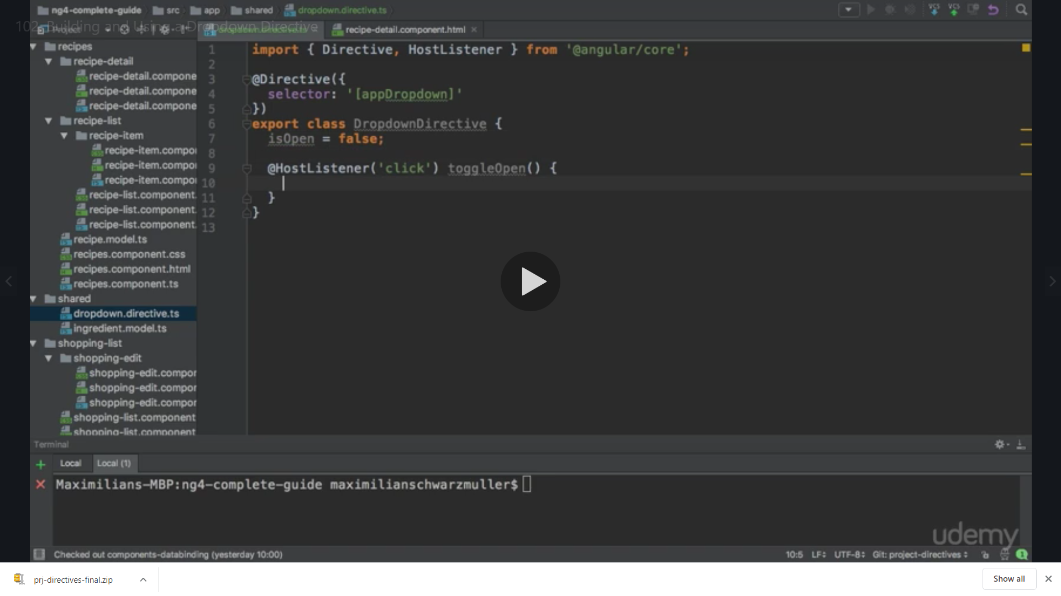

Now we have set it to false

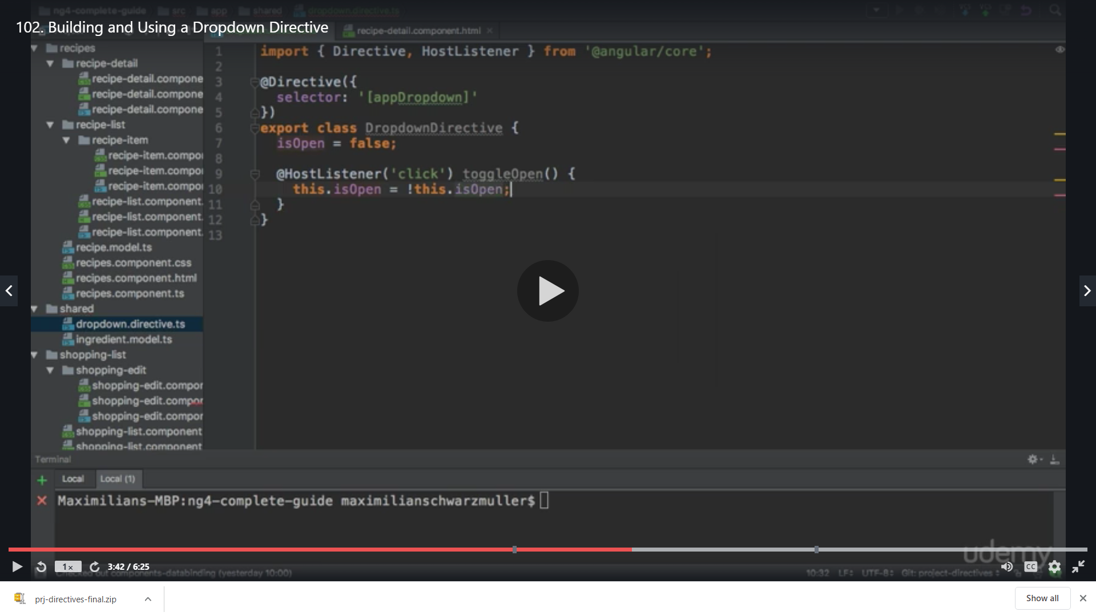

Now to dynamically attach or detach the class ,HostBinding allows us to bind to the property of the element the directive is placed on

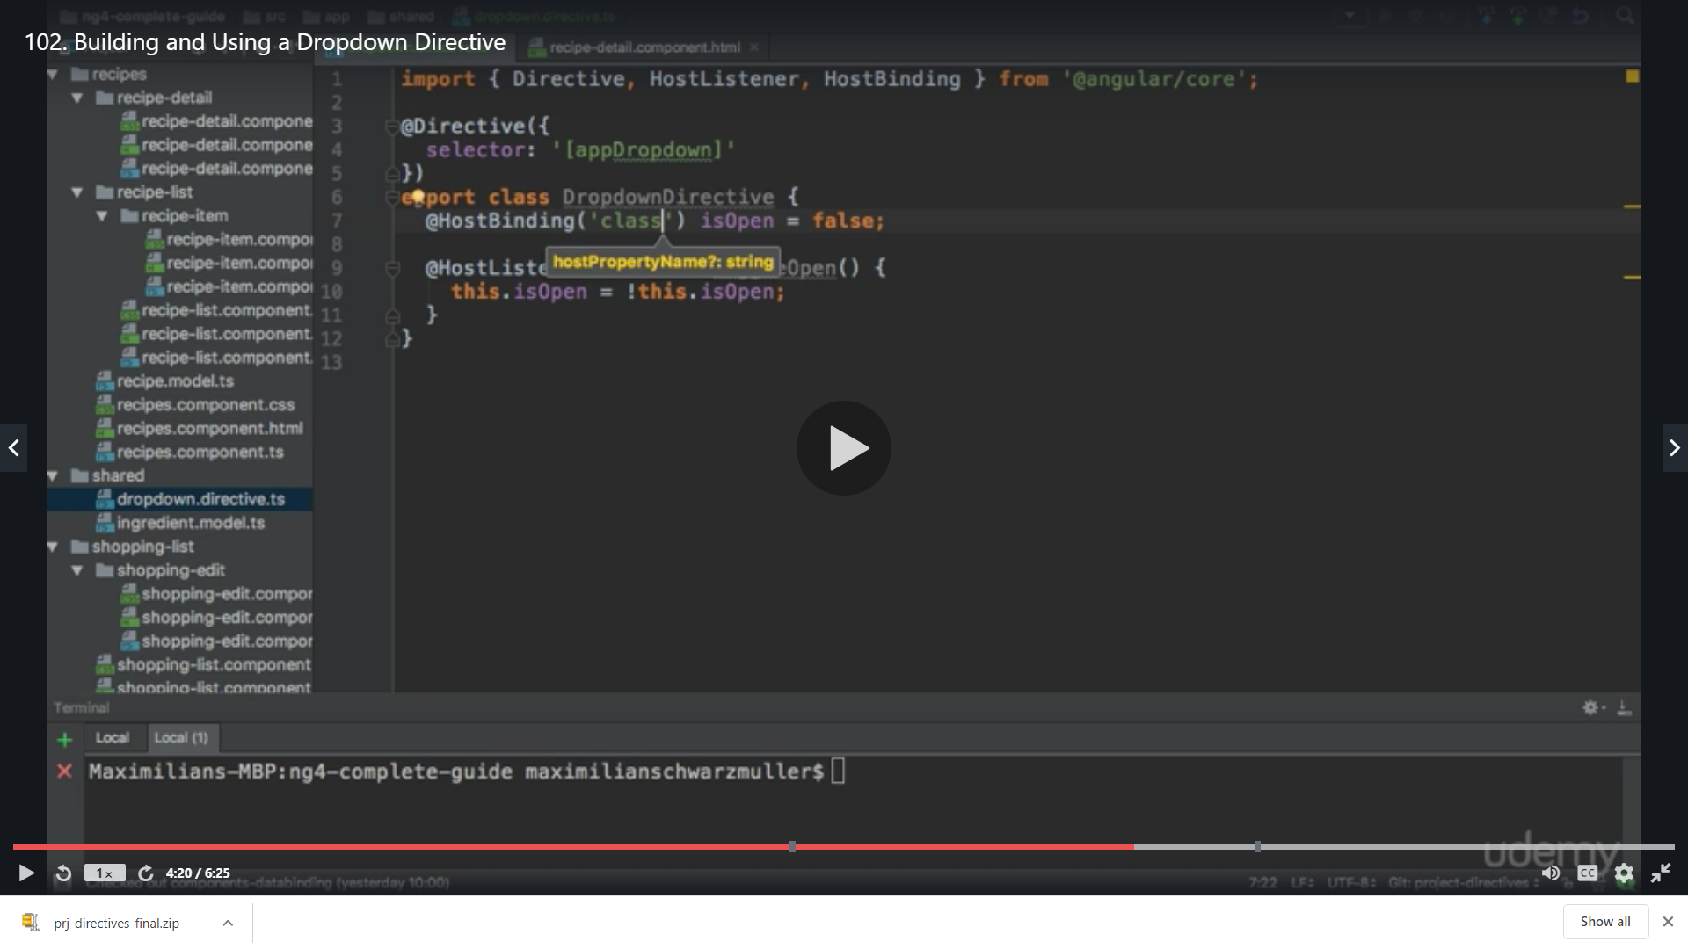

We Bind to the class property of the element

We select the class ie :open from the array of bootstrap classes

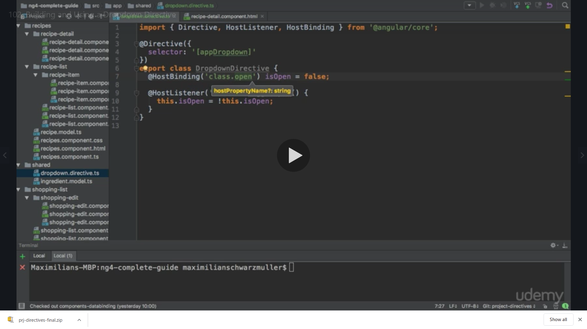

This class will not attach initially whenever it is set to true then it will be attached and , now in order to use it we have created it manually so we need to make entry

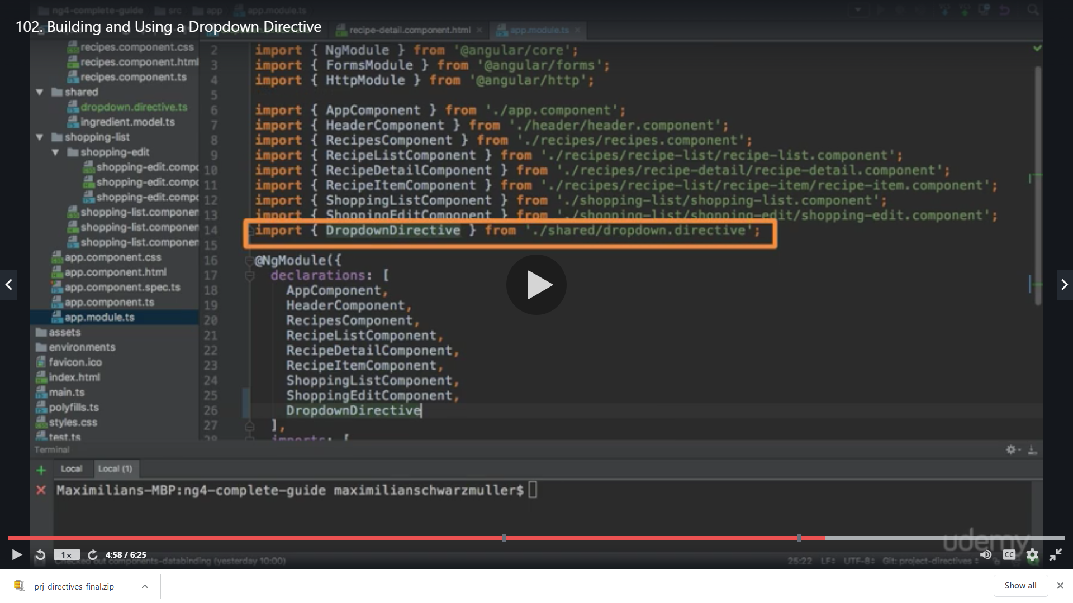

Now we can use it in the detail component

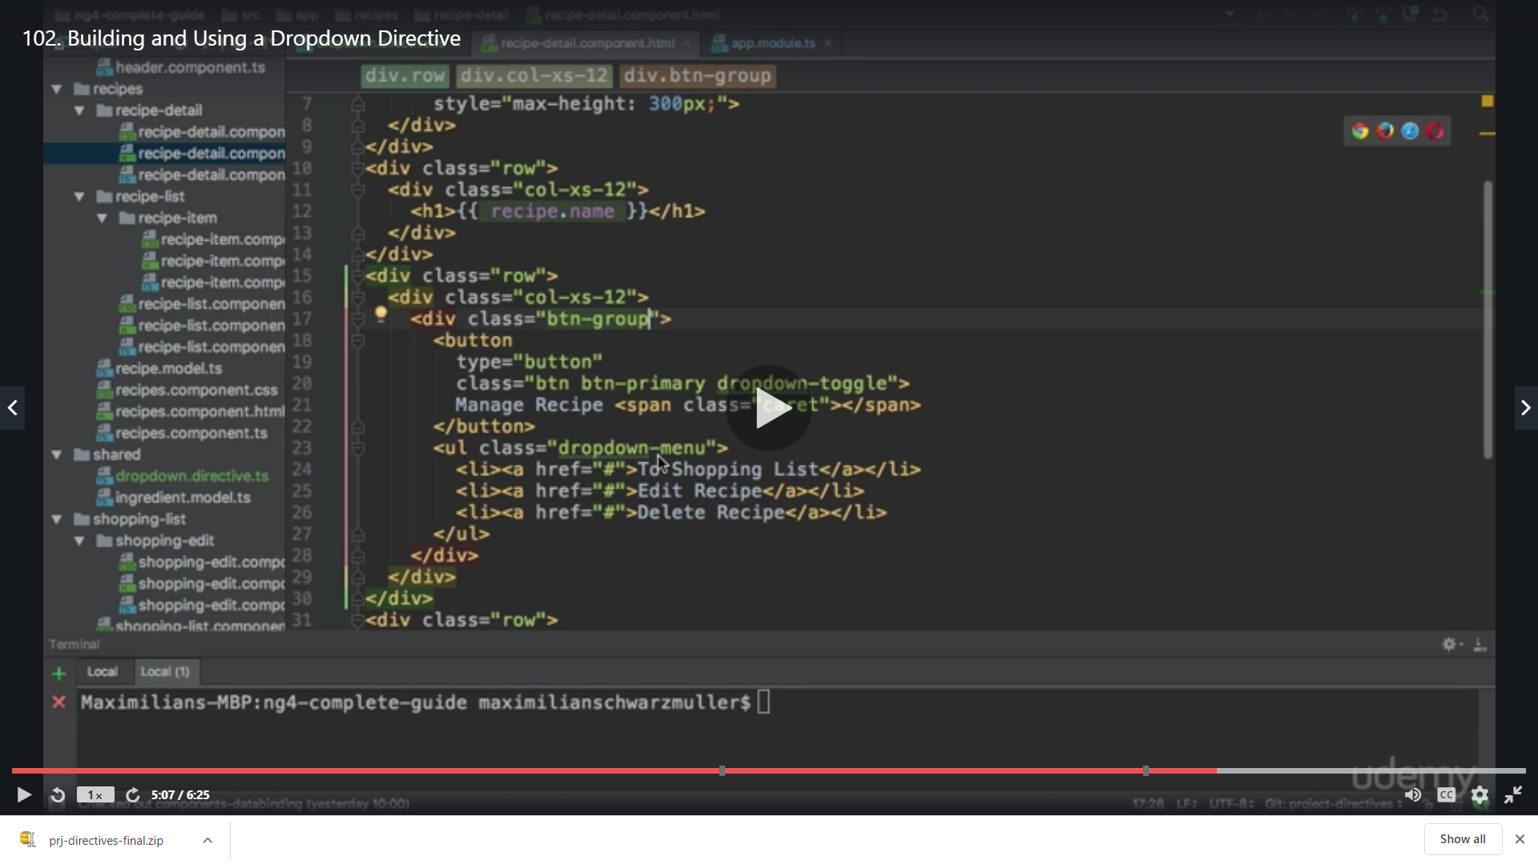

We remove open that we added it was just to show that how it works ,now add our directive to add class dynamically

We do not use square bracket and without assigning any value

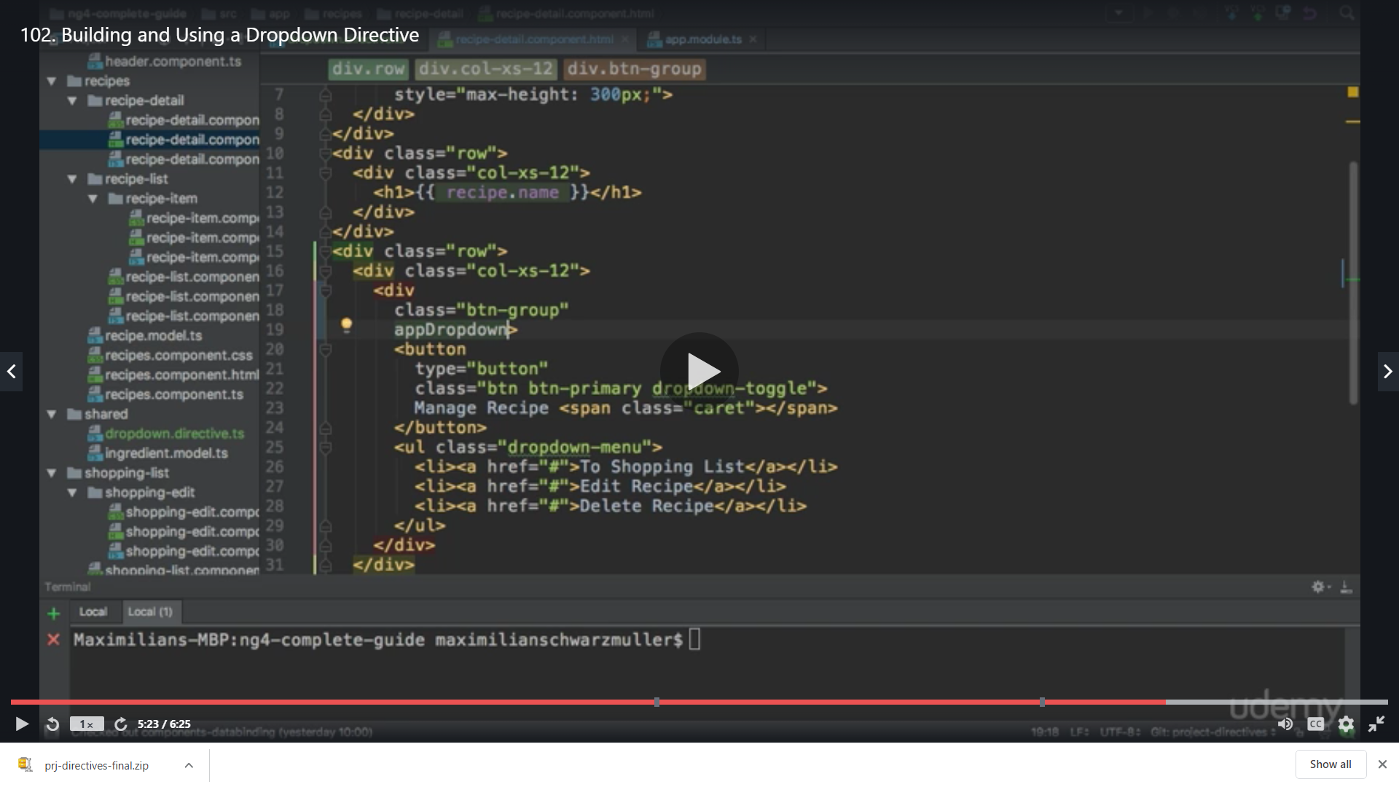

We don’t need to configure anything more to this dirtective

And now in the header

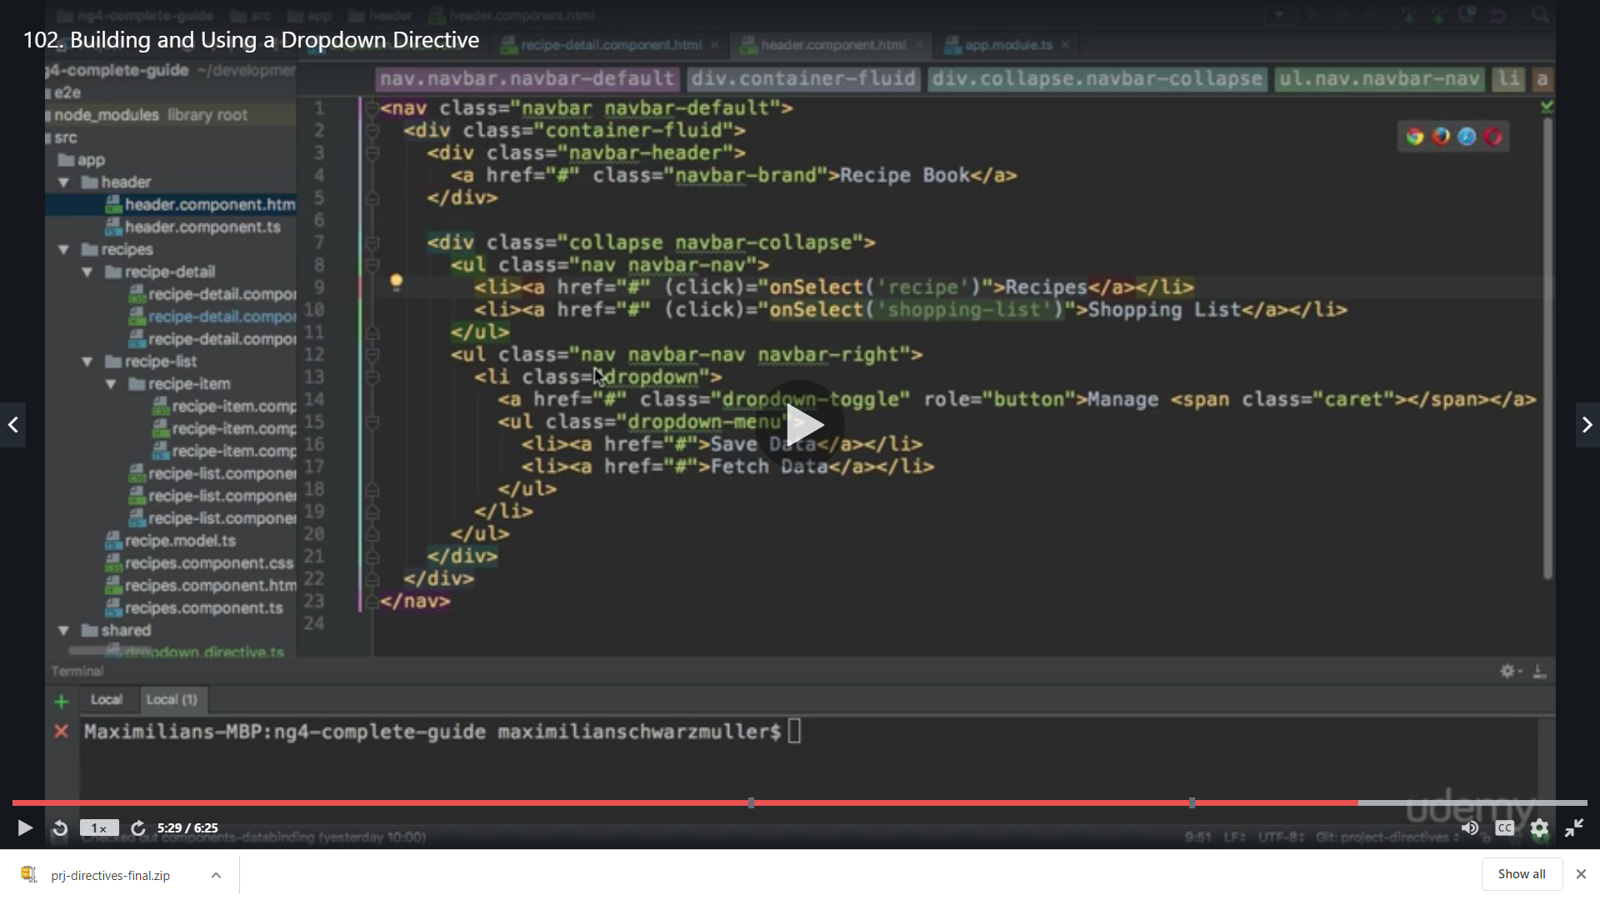

We add our directive here as well

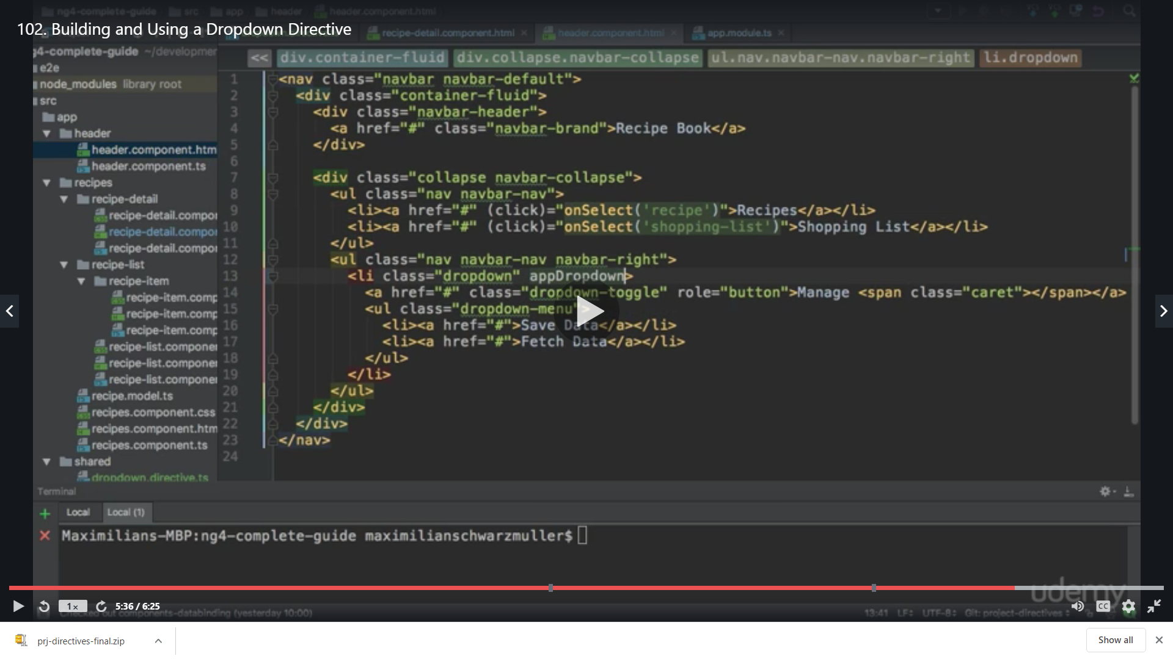

Result

Click manage

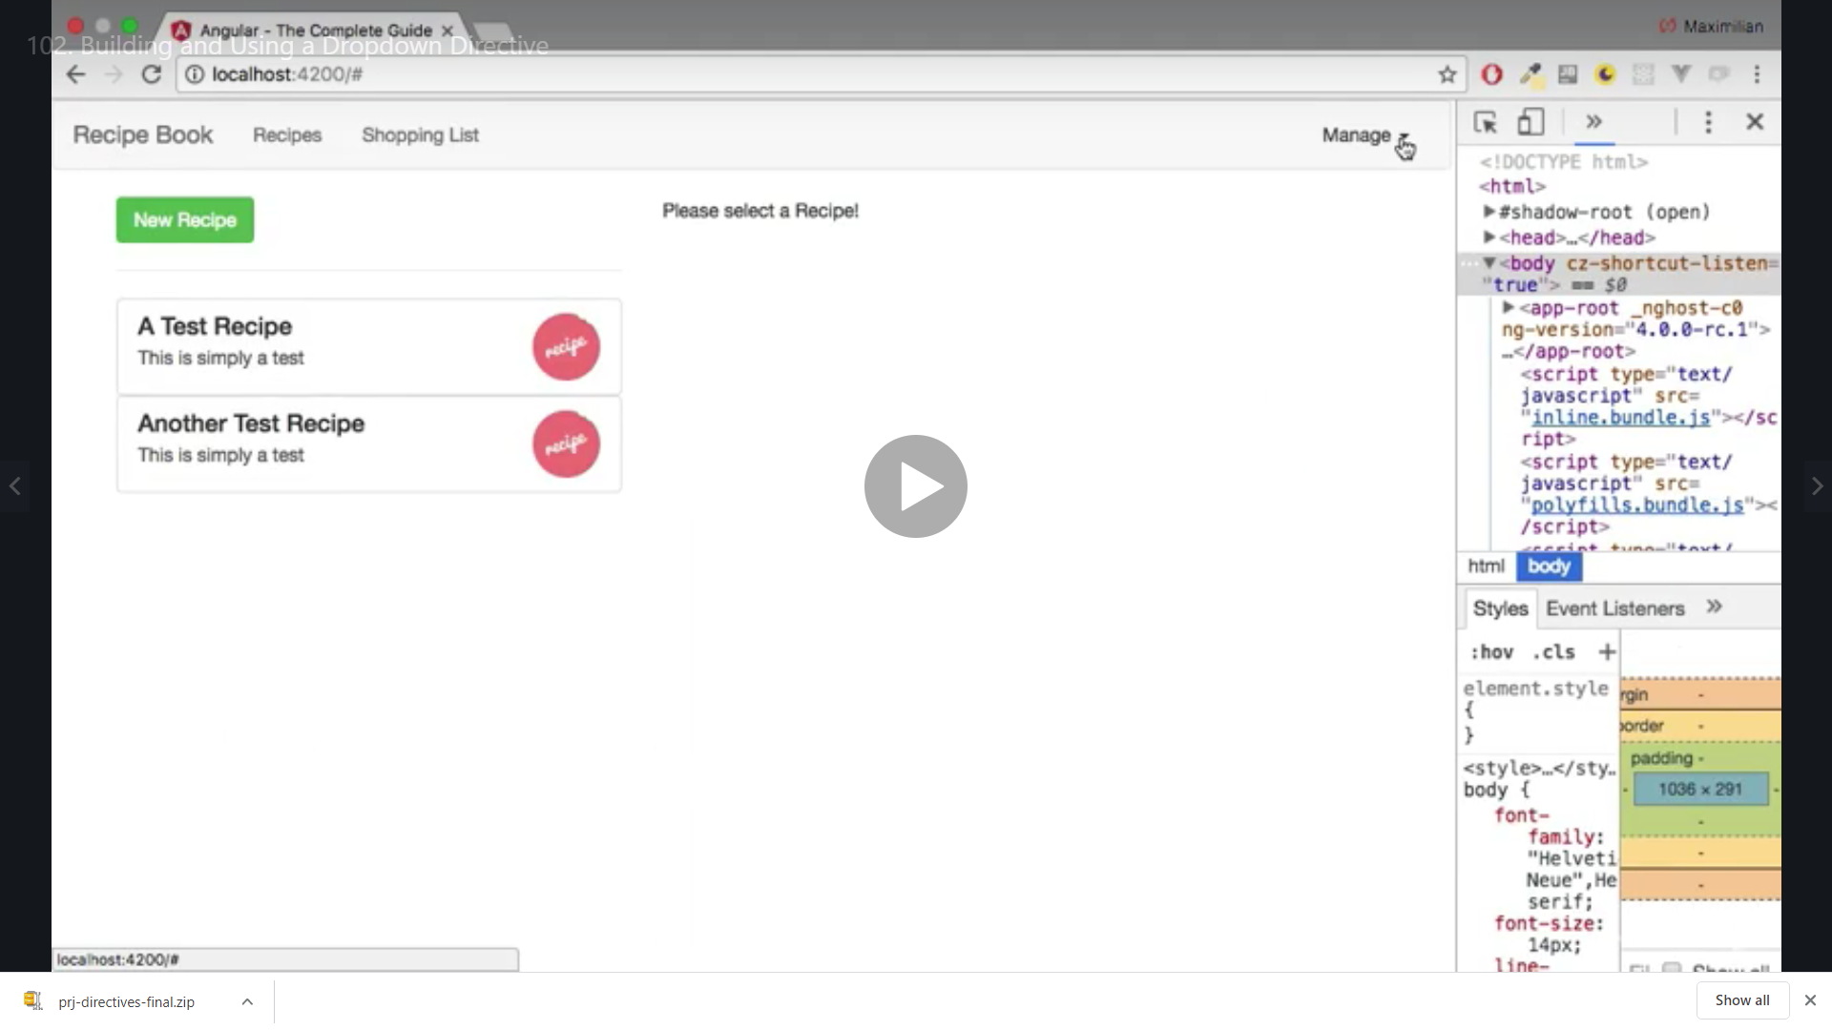

We get the dropdown now because of our directive

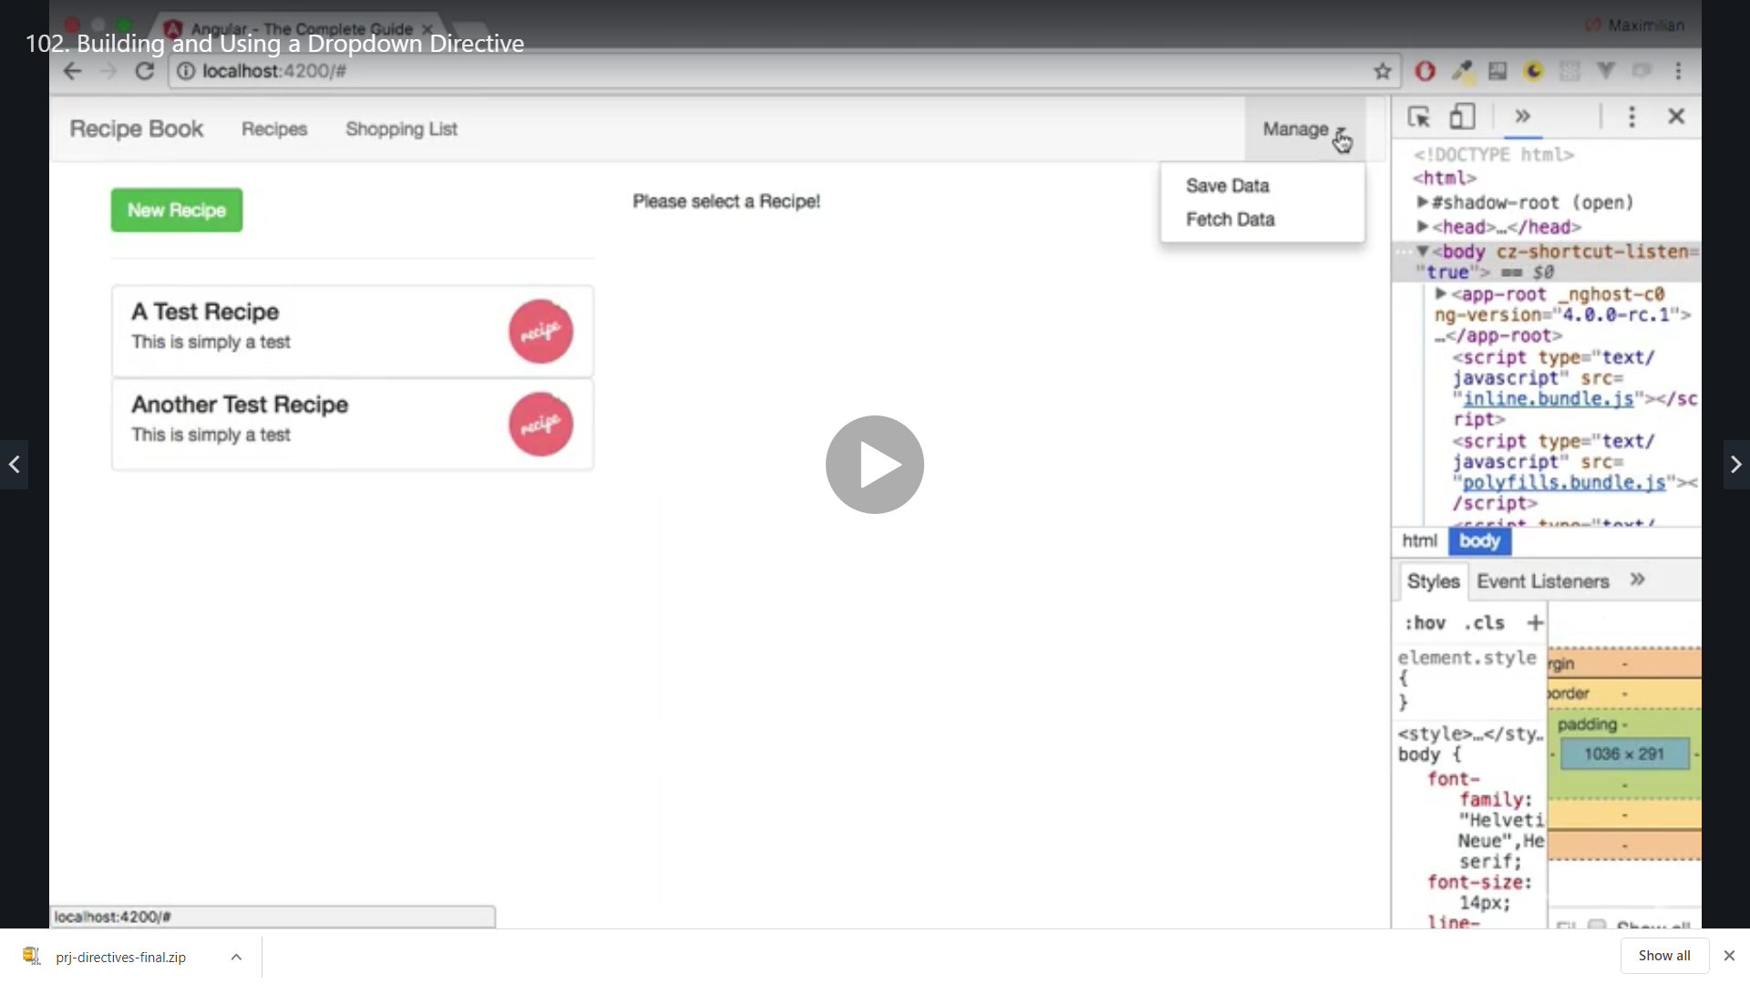

All stuff is working

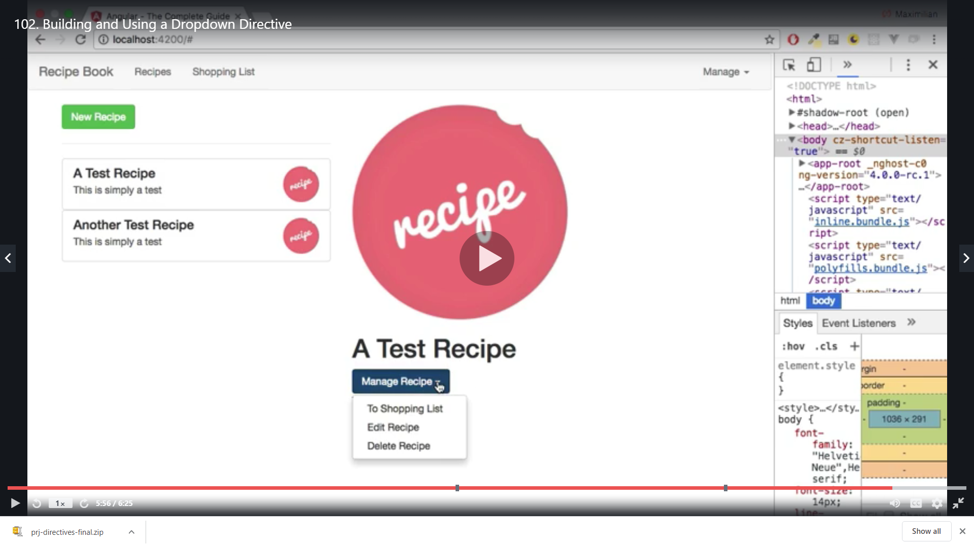

Closing the Dropdown From Anywhere

If you want that a dropdown can also be closed by a click anywhere outside (which also means that a click on one dropdown closes any other one, btw.), replace the code of dropdown.directive.ts by this one (placing the listener not on the dropdown, but on the document):

1. import {Directive, ElementRef, HostBinding, HostListener} from '@angular/core';
3. @Directive({
4. selector: '[appDropdown]'
5. })
6. export class DropdownDirective {
7. @HostBinding('class.open') isOpen = false;
8. @HostListener('document:click', ['$event']) toggleOpen(event: Event) {
9. this.isOpen = this.elRef.nativeElement.contains(event.target) ? !this.isOpen : false;
10. }
11. constructor(private elRef: ElementRef) {}
12. }